**A REPORT OF THE FIELD ATTACHMENT UNDERTAKEN AT MIGORI COUNTY ICT OFFICE FROM 10TH MAY TO 10TH AUGUST 2023 AND SUBMITTED TO INFORMATION TECHNOLOGY DEPARTMENT, DEDAN KIMATHI UNIVERSITY OF TECHNOLOGY.**



**DEDAN KIATHI UNIVERSITY OF TECHNOLOGY.**

**BY**

**BRUNO ODWUOR OYUKO**

**REG.NUMBER: C027-01-1436/2019**

## DECLARATION.

**DECLARATION BY THE STUDENT**

I hereby declare that all information in this document has been obtained and presented in accordance with academic rules and ethical conduct. I also declare that, as required by these rules and conduct, I have fully written this report based on truth and cited all activities and duties that I undertook while on attachment. I therefore declare that this material is original.

NAME: BRUNO ODWUOR OYUKO

REG.NUMBER: CO27-01-1436/2019

Signature..................................................Date.....................................

**DECLARATION BY THE SUPERVISOR**

This attachment report has been submitted with my approval as the Migori ict supervisor.

NAME: ………………………………………………………………………………….

Signature ……………………………... Date…………………………………….

**DEDICATION**

I wish to dedicate this work to my family for supporting me throughout my study.

## ACKNOWLEDGEMENTS

The development of this report took the effort, support and guidance of a number of people whom I wish to thank. I also wish to pay tribute to the management and staff of Migori ict office for offering me a chance to be part of them and for their unwavering support. Gratitude to my academic and Industrial attachment supervisors Mr. Patrick Gikunda for his efforts to assess me and Mr. Paul Mangiteni for their advice on how to improve my skills.

I also thank my family for their support and prayers not only during my attachment period but throughout my course. I cannot end this list without paying tribute to the entire Dedan Kimathi University of Technology department of Information Technology for their constructive training and the knowledge they have imparted in me.

Contents

DECLARATION. i

ACKNOWLEDGEMENTS iii

ABSTRACT v

CHAPTER ONE 1

1.0 INTRODUCTION 1

1.1 OBJECTIVES OF ATTACHMENT 1

1.2 BENEFITS TO STUDENTS 2

1.3 EXPERIENCE 2

CHAPTER 2 3

2.0 Background of Mombasa Law Courts 3

2.1 Mission, vision and core values 4

2.1.1 Vision 4

2.1.2 Mission 4

2.2.3 Core Values 4

2.2 Organizational structure 5

CHAPTER 3 6

3.1 Attachment experiences 6

3.2 problems experienced 6

CHAPTER 4 7

4.1 Knowledge and skills gained 7

CHAPTER 5 8

5.1 Summary 8

5.2 Conclusion 9

5.4 Recommendation 9

References 10

Figure 1Court Hierarchy 5

Figure 2: Staff Hierarchy 5

## ABSTRACT

The purpose of this report is to provide the details of the intuition of attachment, a description of all the activities undertaken during the same, the lessons learnt and challenges during the attachment period. The essence of attachment is to put all the theoretical work done in class by a student into practical exercise.

I was therefore attached at Migori ICT office for a period of three months. The major activities I carried out included computer maintenance, end-user support to litigants on virtual meeting and other staffs, checking switch status, Replacement of UPS machines, Installation of windows OS, Internet troubleshooting/Network configuration, Installation of printer drivers, Arranging IT stores, Ethernet cable crimping, animation design and video editing using Filmora 9 software.

## CHAPTER ONE

## 1.0 INTRODUCTION

The industrial attachment training is an essential component of the curriculum of Dedan Kimathi University of Technology and therefore no graduation without the industrial attachment. The attachment period is usually maximum of twelve weeks, during which the student is expected to acquire additional practical experience to supplement their course of study in the related industry. They are also exposed to the real world of work and its challenges which will prepare them towards their future careers.

This report is the outcome of the Twelve weeks practical training I had at Migori ict office.

## 1.1 OBJECTIVES OF ATTACHMENT

Some of the important objectives of the industrial attachment are as follows

* To assess the interest of the student in the occupation he/she plans to undertake.
* To expose the students to work methods not taught at the university and to provide access to products equipment not normally available in the environment of the School.
* To provide the students with an opportunity to apply knowledge in real work situation thereby closing the gap between school work and the actual practice.
* To make the transition from school to the world of work smoothly and to enhance student contacts for job placement.
* To enlist and strengthen employer’s involvement in institutional activities and in the entire educational process of preparing the students for employment in industry.
* To enhance industry´s satisfaction with the graduate of the Faculty in particular and the college at large.

## 1.2 BENEFITS TO STUDENTS

The industrial attachment seeks to offer students a practical translation of the theory they have been taught. It has also got individual benefit of liaising the university to the industries, hence brightening the employment chances of the students in the university. Through this attachment, I have generated a good interpersonal relationship through my interaction with my supervisors and colleagues. This has assisted me to interact confidently with people irrespective of the position.

## 1.3 EXPERIENCE

Through my attachment, I have gained experience in computer maintenance, basic networking skills, end-user support skills, Video editing using Filmora and animation creation using Adobe Illustrator, Adobe after Effects and Adobe Character Animator to create mediation and customer care videos.

## CHAPTER 2

## 2.0 Background of Mombasa Law Courts

On 30th August 1984 the new Law Courts were opened in Mombasa, but where had justice been dispensed beforehand? A British court, presided over by an English barrister, had been established in a godown near the old harbour in Mombasa in 1890, when the Imperial British East Africa Company was in charge of the area. In about 1898 the court moved into the old police headquarters opposite the entrance to Fort Jesus (where the curio market now is). Then magnificent new premises were built in Fort Jesus (now Nkrumah) Road. On 31 December 1902 a fine building to house the law courts, as shown below, was opened by the Commissioner, Sir Charles Eliot, and the High Court based in Zanzibar moved to Mombasa. To begin with the judiciary followed the practices of Bombay’s High Court and was staffed almost entirely by personnel trained in India. In 1911 the High Court was transferred from this building to Nairobi, and British Indian legal practices ceased to be observed. Instead, the practices of English law were substituted. Non-High Court cases were still heard in Mombasa.

The building material used was coral rag bound with lime mortar and faced with plaster. A deep arcaded veranda surrounded the building on the ground floor, supporting an open-air balcony above. It was more usual in this style of building for the upper balconies to be enclosed. Everywhere internally they used dark, solid, well-carpentered wood for doors, staircases, shutters, balconies and floors. Teak was the wood generally used, for it was almost impervious to white ants.

The Law Courts has a central block faced with seven roman arches and flanked with symmetrical wings. Broad steps lead up to the entrance (now shaded by a huge neem tree), topped by a clock tower. The clock chimed every hour and was used as Mombasa’s standard timepiece. The entrance hall has an interesting and massive stone, dated 1677, set into the wall. The inscription on the plaque below reads: ‘The above inscription was taken from the ruins of Fort St Joseph erected by the Portuguese between Ras Serani and Ras Mzimli Mombasa.’

Beyond the entrance hall is a courtyard, from which leads a double staircase, with carved newel posts, to the floors above. The panelled main courts lay on either side of the central block. Beyond the courtyard lay the law library, filled with old law reports and annual gazettes listing all the cases to be heard. At the back of the building were the lavatories, one for each category of prisoner, and the cells. There was also what appeared to be a huge bread oven but was in fact a furnace used by the next-door Treasury for burning out-of-use old banknotes. If convicted, defendants at the courts had only a short journey to Mombasa jail, housed next door in the lofty and impregnable Fort Jesus. The white prisoners incarcerated therein had their meals brought to them from Mombasa Club next door.

What happened to this splendid old building when the law courts were moved to Kizingo? It was converted into an informal gallery, with regularly changing displays of local art, Kenyan crafts, school competition pieces and votive objects from various tribal groups. Paint peeled off the walls, some of the wooden railings were stacked against walls, and makuti roofing on the courtyard was in tatters. It was a sad end for a splendid building.

But then three or four years ago the building was repossessed by the judiciary. It is being renovated and, in tandem with the National Museums of Kenya, it will become a judiciary exhibition with a temporary gallery available to other parties. A railing has been added to the perimeter wall, which is simple and tastefully designed.

The new Building of Mombasa Law Courts in Kizingo, was officially opened in 1984 by the second president of Kenya Daniel Arap Moi. It’s the second largest Law courts in Kenya. It has a Court of Appeal, High Court, Industrial courts, Land and Environment court, Kadhi’s Court and Magistrate courts including Tononoka children’s court. The main station has registries for both high courts, court of appeal and lower courts. It’s also has archives, cells, library, 15 court rooms, judge’s chambers and magistrate’s chambers.

## 2.1 Mission, vision and core values

## 2.1.1 Vision

An independent institution of excellence in the delivery of justice to all.

## 2.1.2 Mission

To administer justice in a fair, timely, accountable and accessible manner, uphold the rule of law, advance indigenous jurisprudence and protect the constitution.

# 2.2.3 Core Values

The Judiciary is guided by the following core values:

1. Professionalism
2. Integrity
3. Diligence
4. Team work
5. Courage
6. Humility

## 2.2 Organizational structure

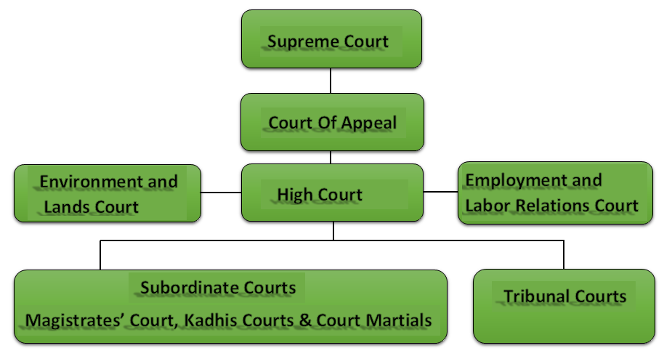Court Hierarchy

Figure 1Court Hierarchy

Staff Hierarchy

PRESIDING JUDGE

## 

CHIEF MAGISTRATE

DEPUTY REGISTRAR

COURT ADMINISTRATOR

SUPPORT STAFF

Figure 2: Staff Hierarchy

## CHAPTER 3

## 3.1 Attachment experiences

General activities I under carried include;

* Computer Maintenance and Support
* End-User Support to staff and Litigants in accessing their court sessions online.
* Networking: Cable crimping, Switch repair and Configuration
* Animation Creation and Video Editing
* Cable Management
* Data recovery on external drives and hard disks

## 3.2 problems experienced

At first the attachment period was not enjoyable since I had to familiarize with both workmates and the working environment.

## CHAPTER 4

## 4.1 Knowledge and skills gained

The knowledge and skills acquired during the course of my attachment forms the bedrock of my future career development. The entire activities carried out in Mombasa Law Courts will go a long way in ensuring my application of the knowledge and skills in any entity and undertaking that I may find myself into. Therefore, I am confident in applying the knowledge I have learnt in any company that may give me an opportunity to offer my services in my career.

## CHAPTER 5

## 5.1 Summary

Based on the above report and skills gained, I believe will be perfect bedrock for my future career. My work related learning period at the Mombasa Law Courts really transformed me into a responsible student who is capable of completely working in an industry. It really gave experience of the real working environment. I was able to familiarize myself with new ideas and aspects in the Organization. Now I have finalized my attachment period, I will be able to balance between theories I learnt at school with the practical experience that I gained in the Organization.

The theory that I learnt at school has been transformed to a valuable resource by my time at Mombasa Law Courts. I will have a different stance to the modules that I learnt at school because of the knowledge that I have on the expectation of a Graduate in the society. I have also been transformed personally by the challenges that I faced during my time in the organization as well as the responsibilities that I was given during my time of attachment. I am able to critically analyze situations and make rational decisions. I am now capable of being a leader and this is acquired through being accountable in some tasks, which the management delegated to me. As I accepted the responsibility, it meant that I would devise means and ways to accomplish assigned tasks effectively thereby enhancing my leadership qualities and skills. Regularly reporting to my supervisors really boosted my communication skills.

I am now able to carry out duties without constant supervision, taking my responsibilities with caution and perfectness hence I have become self- initiative. I now know a good employee does not knock-off but gives himself a target each day.

During my time at Mombasa Law Courts I was also groomed to be initiative. I was trained to be original, creative and came up with new ideas. This will have a significant impact in my work environment since I will try as much to be creative with knowledge that I obtained at school.

## 5.2 Conclusion

At first the attachment period was not enjoyable since I had to familiarize with both workmates and the working environment. As time went by it turned out to be very fruitful. I gained experience and skills which are required in ICT Department. I learnt to appropriate that theory without practice is dead, to be patient and being tolerant. I am now a better person due to the attachment experience both at work and personal level. The background, vision, mission and values of Mombasa Law Courts have been explored in great detail. It takes upon itself to do its best in environment and in its social responsibility endeavors in its day-to-day operation.

## 5.4 Recommendation

The management should increase the number of printing papers to the underwriters so that work can be made easier.

## References

Old Africa Stories from East Africa’s Past, Mombasa law courts by Christine Nicholls July 22,2016.

[www.csnicholls.co.uk](http://www.csnicholls.co.uk).

Mombasa law society

The Ease African November 20221. theeastafrican.co.ke.

Benefits of industrial attachment to students and logbooks.(January, 2017) kenyayote, kenyayote.com/benefits-of-industrial-attachment-to-students-and-logbook/

|  |
| --- |
|  |
|  |
|  |

.